--**make new directory**

hadoop fs -mkdir pigGradedAssignment

--**move the input file to hdfs**

hadoop fs -put AirlinesData_sample-1.csv hdfs://nn.cdh2017.com:8020/user/Jig13895/pigGradedAssignment/

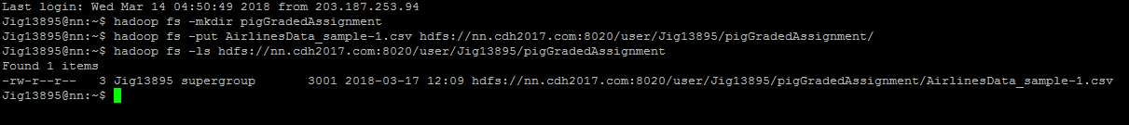

hadoop fs -put Airlines_data.csv hdfs://nn.cdh2017.com:8020/user/Jig13895/pigGradedAssignment/



**--register the necessary jar**

register '/home/data/piggybank.jar';



register '/home/Jig13895/minutes.jar';



**--load input file**

input_file = load 'hdfs://nn.cdh2017.com:8020/user/Jig13895/pigGradedAssignment/ Airlines_data.csv ' using org.apache.pig.piggybank.storage.CSVExcelStorage() AS (year:int,month:int,day:int,dow:int,dtime:int,sdtime:int,arrtime:chararray,sarrtime:chararray,carrier:chararray,flightnum:int,tailnum:chararray,etime:int,setime:int,



**--dump input file**

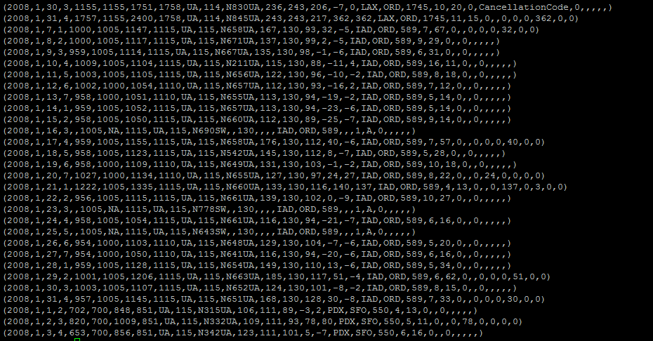

**--filter records by the given year**

filtered_out = FILTER input_file BY year == 2008;



**--transformed input file to convert local time to minutes to compute delay**

ip_file_modified= FOREACH filtered_out generate $0..$28, GetMinutes(arrtime), GetMinutes(sarrtime);



dump ip_file_modified;

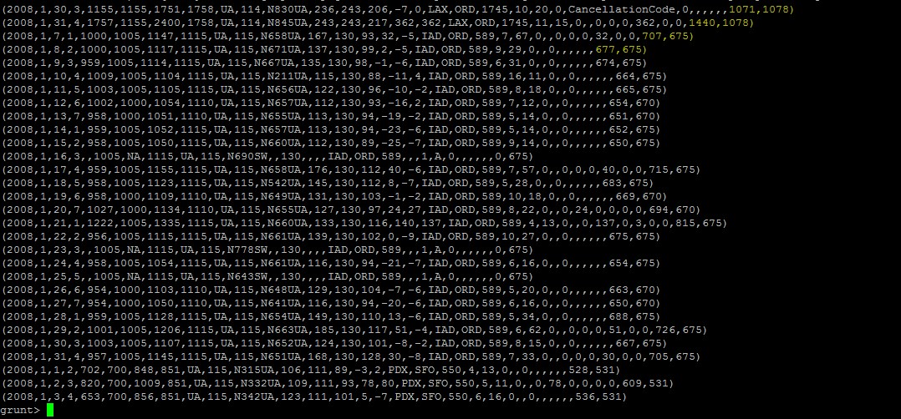

**--type conversion**

iip= FOREACH ip_file_modified generate $0..$28, (int)$29 as newArrTime,(int)$30 as newSArrTime;



describe iip;



**--compute the delay**

modified_out_2= FOREACH iip generate $0..$28,(newArrTime-newSArrTime) as actualdelay;



dump modified_out_2;

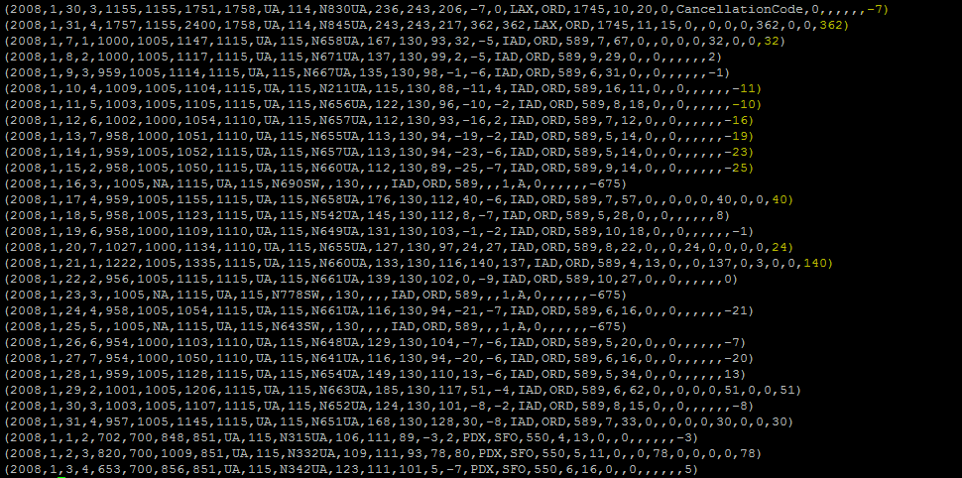

**--group all flights by month**

grouped_out_1= GROUP modified_out_2 by month;



**--filter only delayed flights witm min >15**

delayed_out = FILTER modified_out_2 by actualdelay>15;



dump delayed_out;

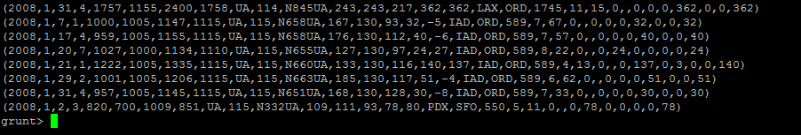

**--group all delayed flights by month**

grouped_out_2= GROUP delayed_out by month;



**--compute the total number of delayed flights for each month**

delayPerMonth= FOREACH grouped_out_2 generate group,COUNT(delayed_out.flightnum);

result= order delayPerMonth by $1;

dump result;

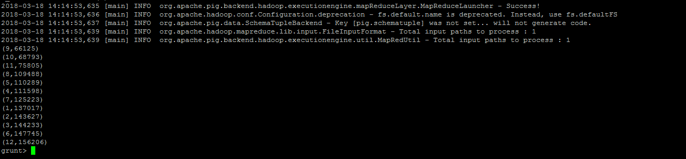

**o/p:**

(9,66125)

(10,68793)

(11,75805)

(8,109488)

(5,110289)

(4,111598)

(7,125223)

(1,137017)

(2,143627)

(3,144233)

(6,147745)

(12,156206)

**-- compute the total number of flights**

grouped_out_3= GROUP modified_out_2 All;

ttlFlights= FOREACH grouped_out_3 generate COUNT(modified_out_2.flightnum);



dump ttlFlights;



**Total flights count -> o/p**: 7009738

**-- compute the total number of delayed flights**

grouped_out_7= GROUP delayed_out All;

ttlDelayedFlights= FOREACH grouped_out_7 generate COUNT(delayed_out.flightnum);



dump ttlDelayedFlights;



**Total delayed flights count -> o/p**: 1396149

**•Fraction delay from the departure**

**--from the delayed out filter records where departure delay>15 min**

dept_delay_out= FILTER delayed_out BY $15>15;

**--compute the total number of delayed flights for each month due to departure delay**

grouped_out_4= GROUP dept_delay_out by month;

dept_delayPerMonth= FOREACH grouped_out_4 generate group,COUNT(dept_delay_out.flightnum);



dump dept_delayPerMonth;

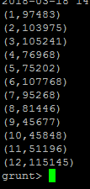

**•Fraction delay due to carrier**

**--from the delayed out filter records where carrire delay>15 min**

carrier_delay_out= FILTER delayed_out BY $24>15;

**--compute the total number of delayed flights for each month due to carrier delay**

grouped_out_5= GROUP carrier_delay_out by month;

carrier_delayPerMonth= FOREACH grouped_out_5 generate group,COUNT(carrier_delay_out.flightnum);



dump carrier_delayPerMonth;

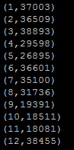

**•Fraction delay due to weather**

**--from the delayed out filter records where weather delay>15 min**

weather_delay_out= FILTER delayed_out BY $25>15;

**--compute the total number of delayed flights for each month due to weather delay**

grouped_out_6= GROUP weather_delay_out by month;

weather_delayPerMonth= FOREACH grouped_out_6 generate group,COUNT(weather_delay_out.flightnum);



dump weather_delayPerMonth;

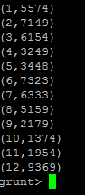

**Attached is the complete scripts **